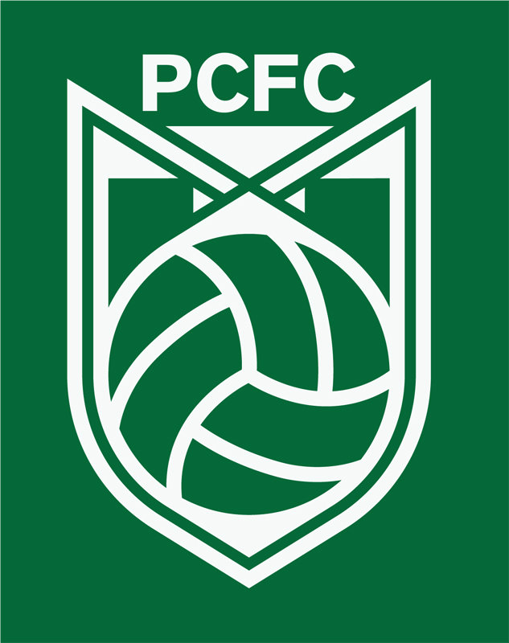
Ocires Morales, Head Coach, U11 Travel Team & U10 Dev. Team

I am Ocires Morales. I’m from Mexico and I’ve been in the USA for 15 years. I’ve been coaching for two years. I started as a parent who wants to be involved with their kids, but I realized I can help others kid’s lives by playing this beautiful sport. I’m working on getting more coaching skills so the kids can learn high quality soccer. As a player I like to play right or left wing, but don’t have the same speed as when I was a kid! But I tried my best to help my team - sometimes I end up being the goalkeeper!

